My name is Konrad
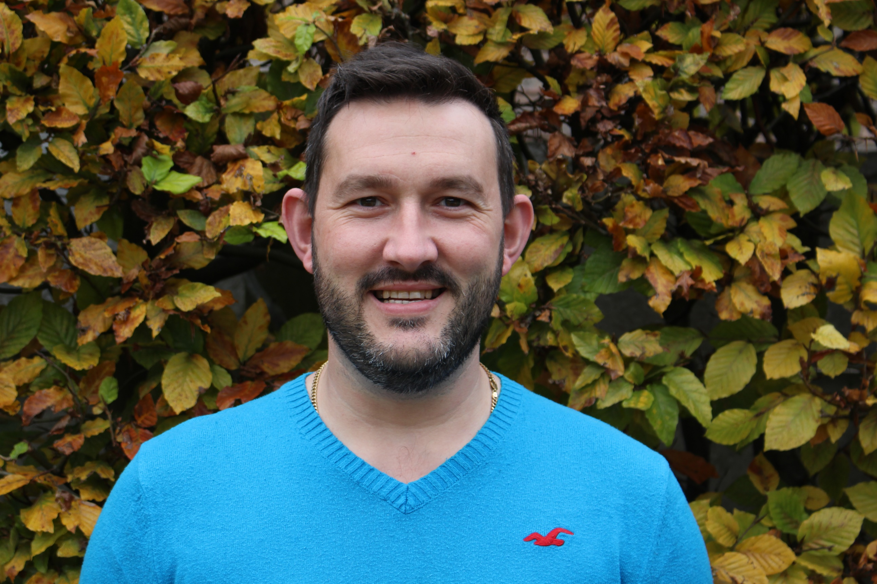
I am working on your corridor today

