
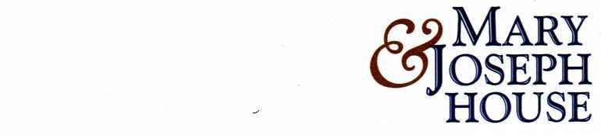
PERSON SPECIFICATION

Job Title: Therapeutic Art Worker
CHARACTERISTIC | ESSENTIAL | DESIRABLE
EDUCATION/  QUALIFICATIONS/  TRAINING | Have a recognised qualification: minimum Diploma in Art & Design or equivalent  GCSE or equivalent in Maths & English | Willingness to attend relevant training in mental health and/or alcohol related issues.
SKILLS/KNOWLEDGE | Computer literate  Good communication skills  Ability to follow written & verbal instructions.  Basic numeracy & literacy skills.  Accurate record keeping skills. | Health & Safety/Infection Control  Equal Opportunities  Data Protection  Confidentiality
EXPERIENCE | Experience of carrying out risk assessment | Experience of working with clients who display challenging behaviour  Experience of working with vulnerable people  Experience of working in a residential or similar setting.
APPEARANCE/  DISPOSITION | Appearance must be clean & tidy
PERSONALITY/GENERAL INTELIGENCE | Professional, caring and friendly, able to interact with residents, visitors, staff.  Flexible and self motivated, tolerant and enthusiastic.
PHYSICAL REQUIREMENTS AND SPECIAL CIRCUMSTANCES | Good level of physical fitness.

