CQC state of health and adult social care in England 2016/2017

The report includes a positive reference to Mary & Joseph House (page 58) and we were honoured to be invited to the launch of the report in Westminster on Tuesday 10th October2017 <http://www.cqc.org.uk/sites/default/files/20171010_stateofcare1617_report.pdf>

Home Manager Julie Hoszowskyj and Chair of the Management Committee Johanne O’Rourke attended to discuss the findings of the report and the future of Health and Social Care; they also had the opportunity to put questions forward

*(extract from the report)* ***Person-centred care in a high-performing service*** *Mary and Joseph House is a care home in Manchester, providing accommodation and personal care to adult men with enduring mental health needs. A person who used the service said:*

*“The staff here know what they are doing. They have supported me so well, I was close to death when I first arrived, now I am strong and feel great.” Mary and Joseph House check that people have realistic aims and objectives. They want to make sure that, if people are moving out, they have their finances sorted out correctly. There was an example of a person who was due to move back into his family home. The service was supporting him over a number of months, to visit his home regularly, to try and build up links with the community, to find new volunteering opportunities, and to know that he can still come back to Mary and Joseph House for a cup of tea or to have a meal. Arts and creativity were an integral part of the service provided at Mary and Joseph House:  The service had a choir and an instrumental band that had been organised by the staff and people.  A therapeutic gardener and art teacher were employed. The gardening team have worked with the art group to achieve Gold Awards in various Royal Horticultural Society competitions.*

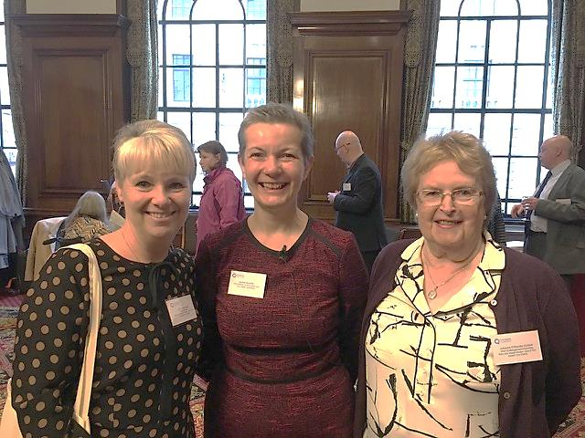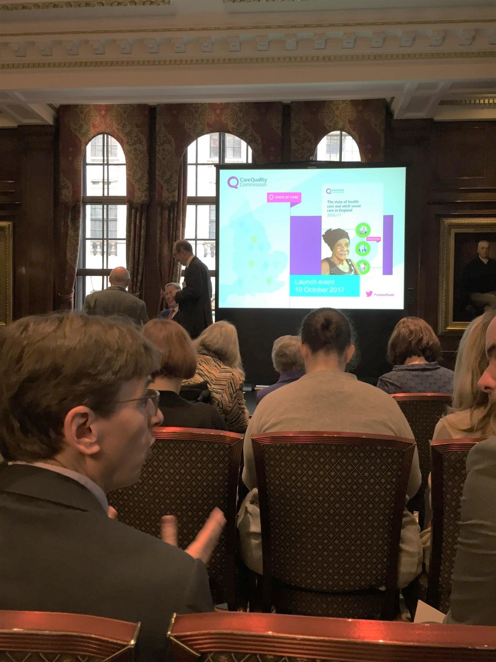Launch of the report at Westminster 10th October 2017

Julie Hoszowskyj (Home Manager), Andrea Sutcliffe (Chief Inspector of Adult Social Care), Johanne O’Rourke, Chair of the Trustees-Mary and Joseph House