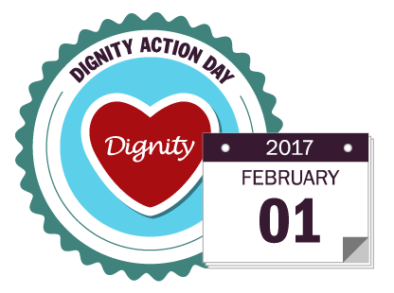

Dignity Action Day“Unity & Togetherness”  
 A quote from one of the residents at Mary and Joseph House about what the day meant to him

Dignity Action Day is an annual opportunity for health and social care workers, and members of the public to uphold people's rights to dignity and provide a truly memorable day for people who use care services and nobody does it better than Mary & Joseph House

Our residents enjoyed an action packed 1950s extravaganza, the dining room was turned into an authentic American Diner which including a juke box, the staff dressed up in 1950s style clothing and the menu on the day included burgers, hot dogs, fries, coleslaw, doughnuts, frothy coffee and milkshakes

Music and entertainment was provided by our house band and “Paul” the DJ, who ensured that the dance floor was never empty

A wonderful day was had by all, and one of our residents put pen to paper to tell us what the day meant to him “Unity & Togetherness” , you can see the full compliment in the testimonial section of our website